Public Program Social Story

Wide Angle Public Film Festival

The Films

Seven films will be screened and you can read about them on the pages following this one.

The Milky Pop Kid, Fiction, AUSTRALIA
(7’00”)
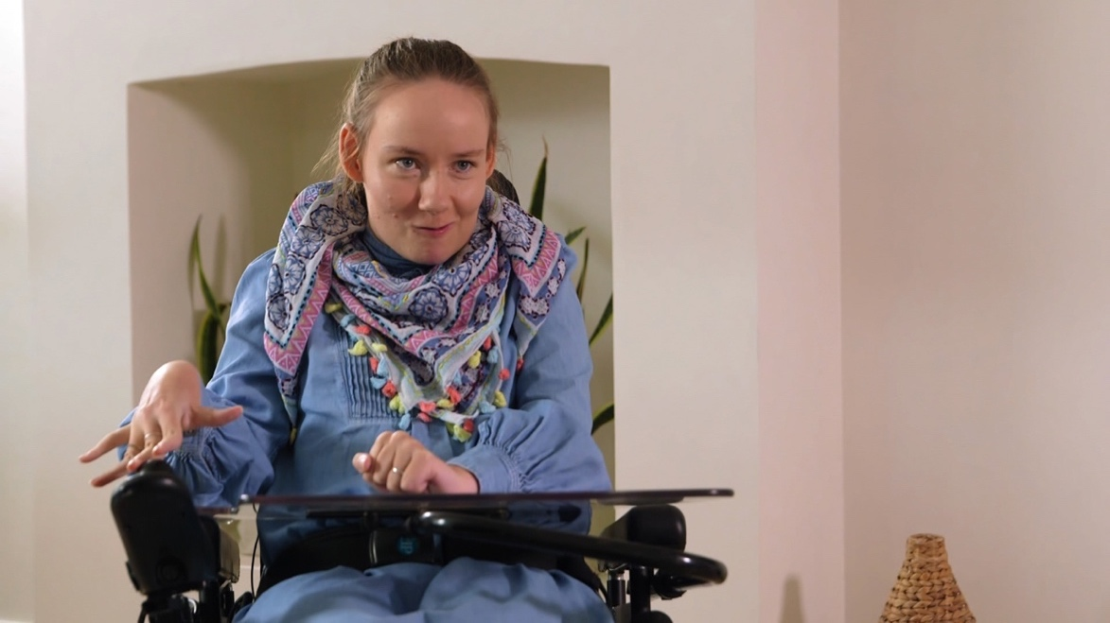

A method actor, best known for his work as a child actor in a famous commercial, has won the role of a solicitor living with disability in a film.
The man decides to consult a woman with disability so that he can be as convincing as possible in the role. He thinks of all the actors without disability who have won awards for playing characters with disability and hopes he might also win an award for this role.
He asks the woman he is consulting to come to his house. The house is at the top of a flight of steps and he has not considered the fact that it is not accessible for the woman who uses a wheelchair.
The woman realises the actor’s naivety and plays small jokes on him, such as getting him to take his shirt off and overfill his mouth with lollies to help him sound like he’s ‘disabled’.
At the end of the film, the woman performs the monologue the man has been rehearsing. There is much more authenticity in her version than in the actors.
Cesar’s Workshop, Non-Fiction, RWANDA
(3’23”)
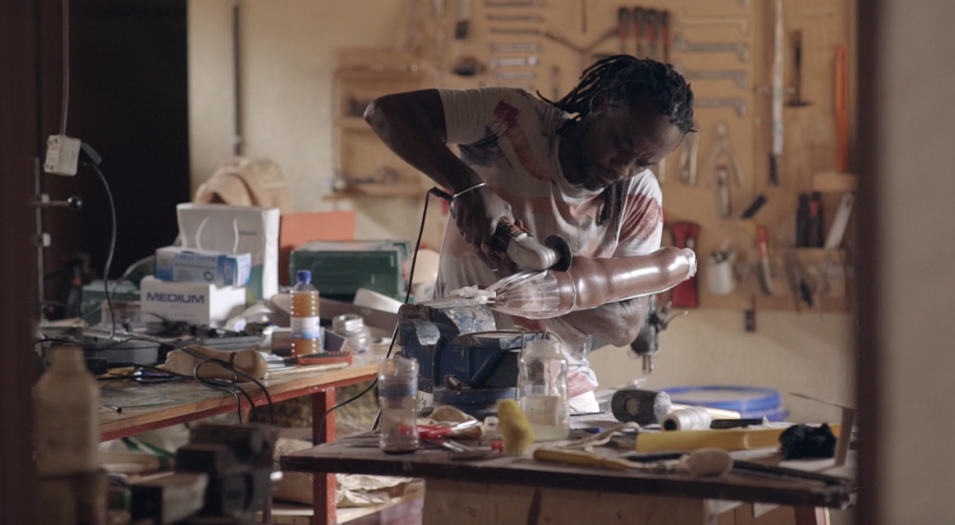

This film is a documentary about Cesar Rwagasana, an ex-Rwandan soldier. Cesar lost his leg in the war and was given a poorly made prosthesis. He wanted to make better prosthesis for himself and others so he taught himself the skills to do so. He feels that one of the reasons he makes great prosthesis is because he has had lived experience of using one.
Cesar collects donated materials. He’s prepared to work with what’s available because he believes a person’s mobility is more important than having perfect materials. We see Cesar using the materials and power tools in his workshop to cut, mould and colour the prosthesis he makes.
Cesar makes a prosthesis specially fitted for a boy who doesn’t have one. The boy looks very nervous at first but is very happy once he starts using the leg and realises he can participate more in life. Cesar hopes that in turn, the boy will go on to help other people too.

Venus, Non-Fiction, U.K.
(5’41”)
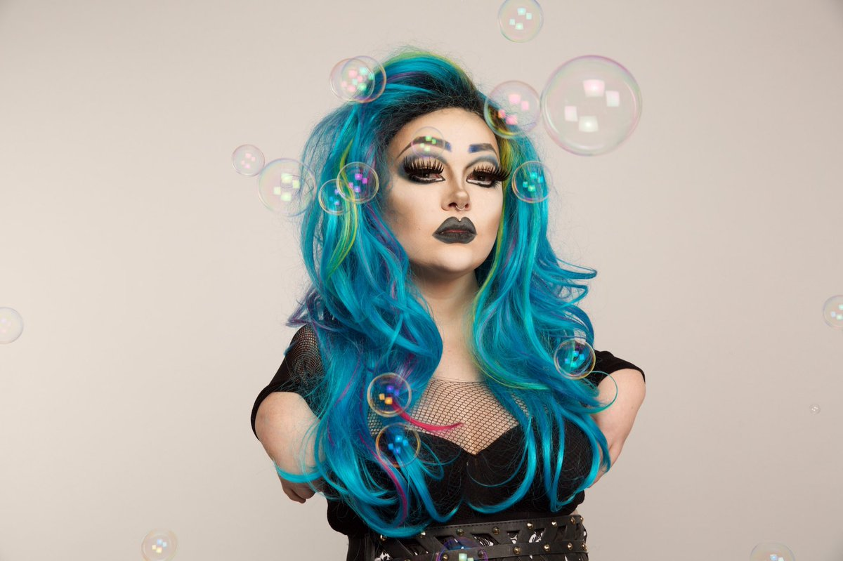

This film is an English documentary about female drag queen, Venus.
Venus lives two parallel lives. In her ordinary life, people feel unnecessary sympathy for her and she allows them to comment on the disability she lives with. As Venus, she feels empowered and does not give people the same liberty.
Venus enjoys being a drag queen because she feels free and it gives her the opportunity to challenge perceptions of disability.

Corey the Warrior, Non-Fiction, AUSTRALIA
(3’00”)
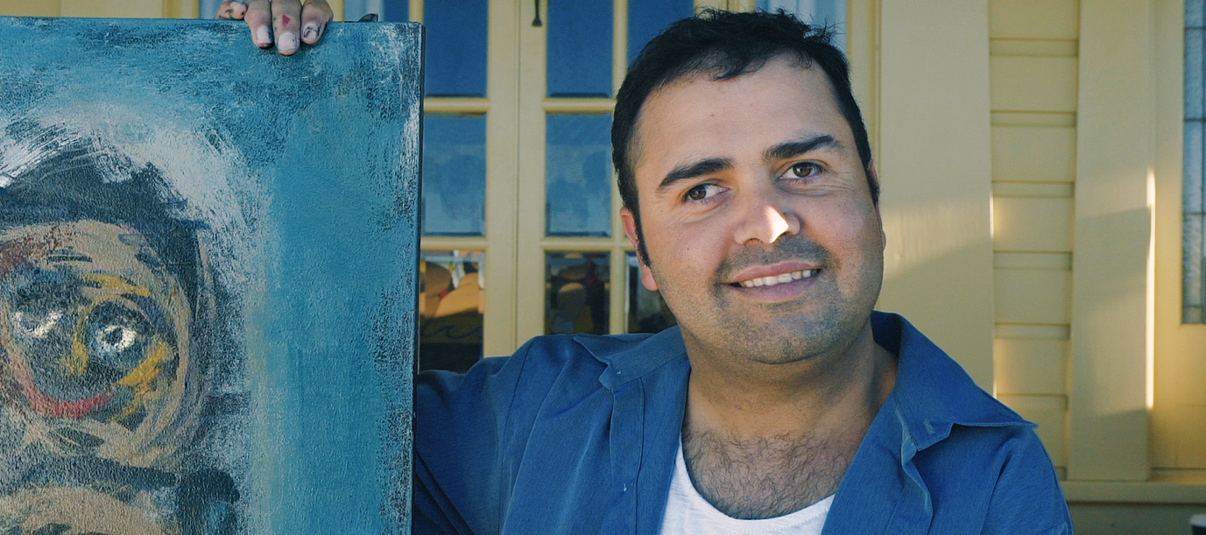

This film is a documentary about Indigenous artist Corey Stewart. Corey acquired a brain injury as a baby, in a car accident with his mother. His mother did not survive the accident.
Corey is a painter, passionate about art and the freedom it brings. He is inspired by nature and culture and is proud of how he’s exceeded people’s expectations.

Prone to the Drone, Fiction, AUSTRALIA
(11’00”)
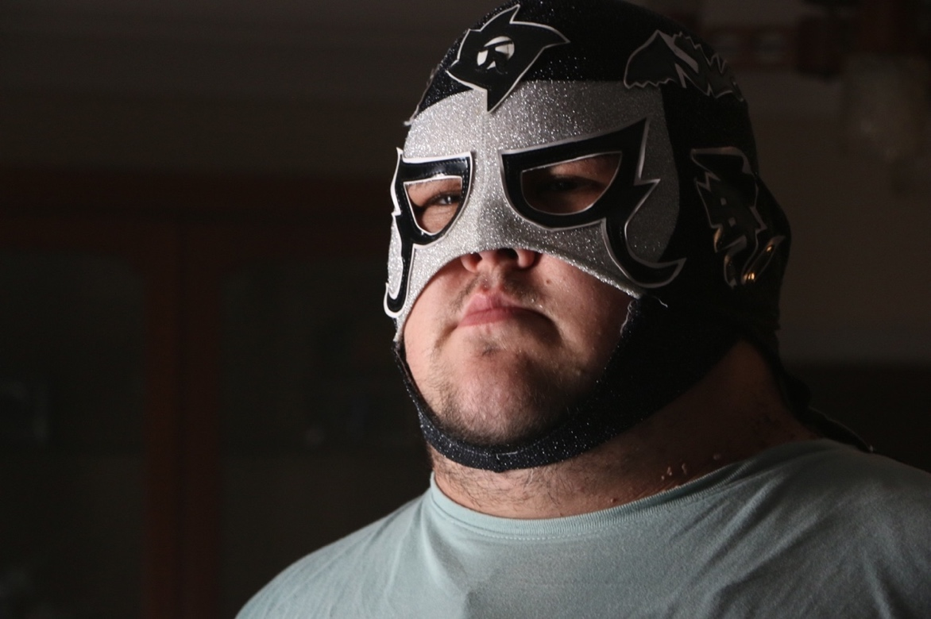

A man living with disability is fearful of the outside world, choosing to isolate himself from others.
Two young boys lose their drone when it flies onto the man’s back porch. They knock on the door to retrieve it but he pretends he isn’t home because he’s too afraid to interact with them.
Once they leave, the man flies the drone himself and the boys see it. They return to the man’s house angrily, shouting and banging on the door. When the drone crashes, the man panics and yells at them to leave. Although he seems aggressive and intimidating, he is scared and starts to cry once back inside.
The boys come back a third time to egg his house but before they do, he comes outside and agrees to fix the drone. A few days later, the boys enjoy flying their drone by the man’s house, as he stands outside in a Hawaiian shirt happy and relaxed.

Re-cal-i-brate, Non-Fiction, AUSTRALIA
(6’00”)
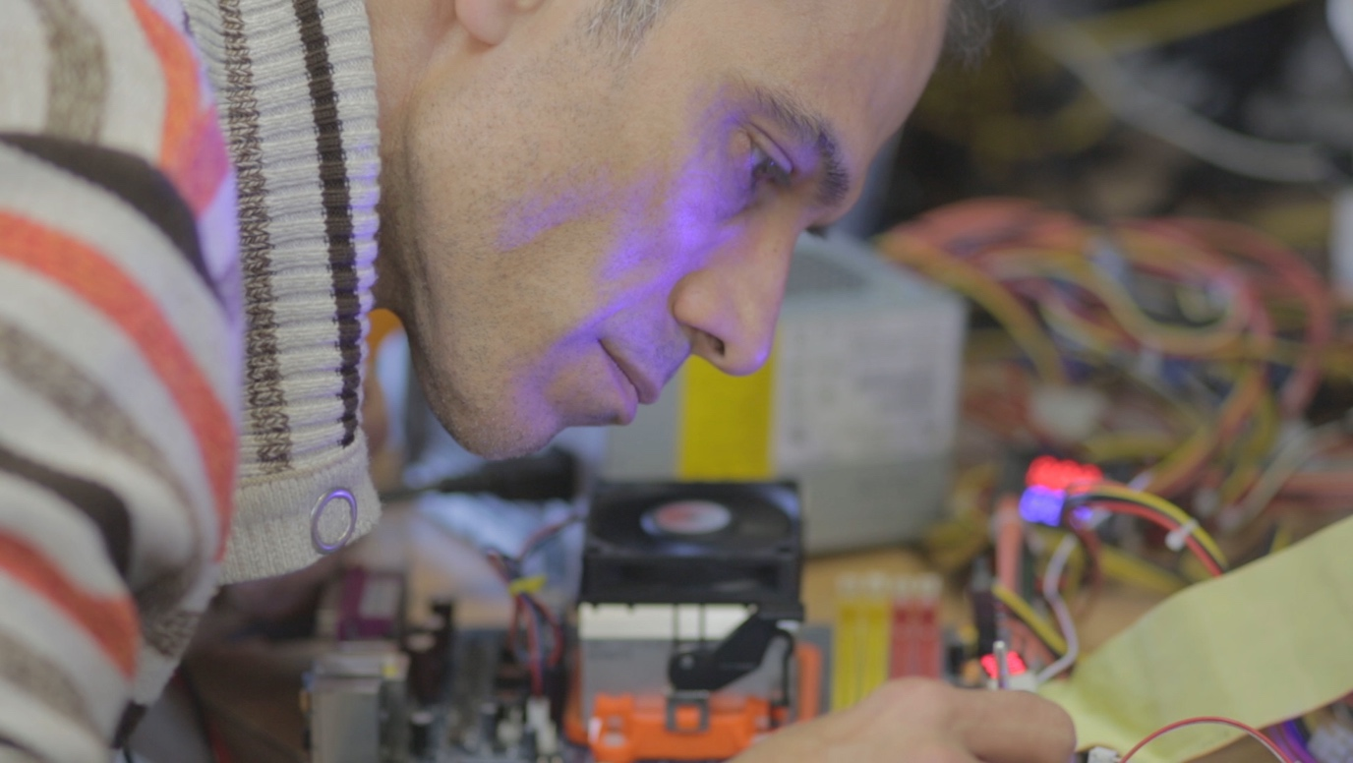

This film is a documentary about an artist who, after travelling to Australia, spent time in a detention centre. He uses invention and art to overcome the trauma suffered as a refugee.
During his time in the camp, he created art by making tools out of anything he could find, including making a paintbrush from cat hair. Creating art helped him to feel free although he was physically captive.
Now out of the detention centre, he works in his own studio as an artist re-using and re-inventing common household items and electronics. He makes projects based on whatever ‘calls’ to him.

Just Go, Fiction, LATVIA
(10’13”)
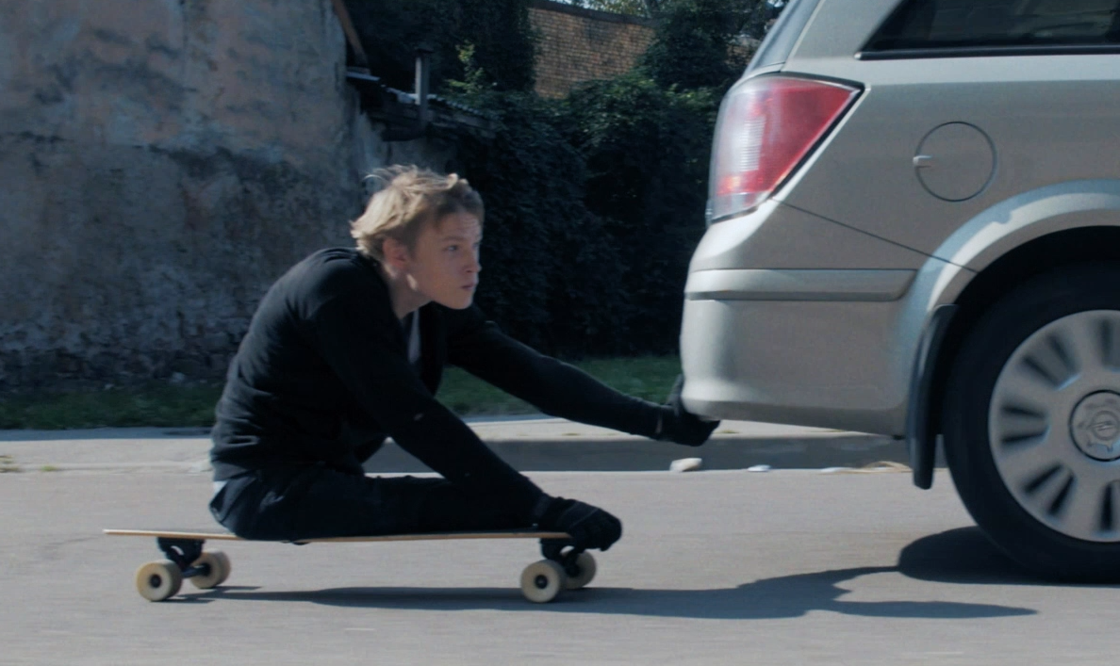

Just (pronounced Yoost) uses a wheelchair. While he’s speaking to a woman he likes, Eva, two men snatch her handbag and run away.
Just begins a long and thrilling chase. He uses his wheelchair, then a car, then a skateboard. Just is extremely fit and athletic and catches up to the criminals. They try to trap him but he grabs the bag and escapes. He also takes a photo of them.
Just jumps on a bus and when he sees the men still chasing him, he makes a phone call. When he gets off the bus, the men corner him again and one takes out a knife. They demand the photo he took of them and threaten to hurt him.
Suddenly Just’s friends arrive. They stand behind him. Some have prosthetic limbs and some use wheelchairs. A 3 legged dog chases the thieves away.
Later, Just returns the handbag to Eva and she is surprised to discover he was able to get her bag back himself.
Text appears on screen sharing information on the life of Alexandrs, the actor who plays Just.
The film continues again. Just is playing sitting volleyball. Eva is watching him and cheering. She thinks she has lost her handbag again and calls for Just. He looks ready to help her but then she finds the bag behind her.
The team call to Just to get his attention. They’re waiting for him to serve the ball.

