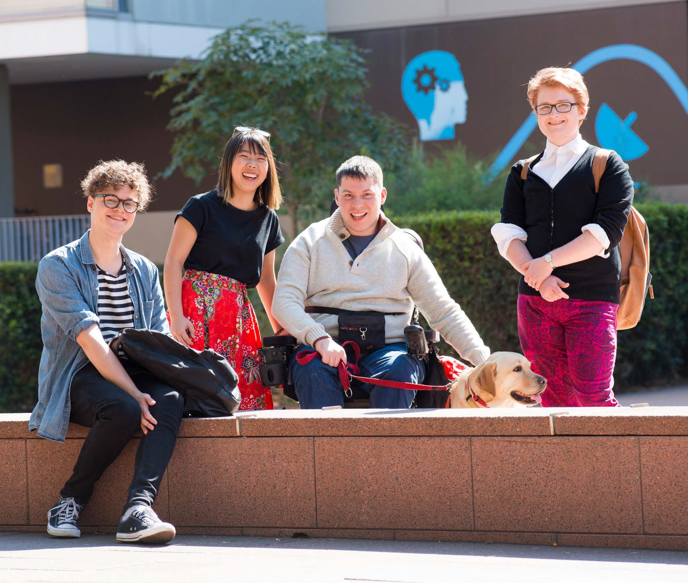
2022 – 2025

Disability Inclusion

Action Plan

2

Contents

From the Vice-Chancellor 4
From the Executive Sponsor 5
Definition of disability 6
Executive summary 8
Summary of progress and achievement 10
Adjusting with impact: about Equitable Learning Services 12
Legislative framework 14
Priorities and actions for the Disability Inclusion
Action Plan 2022 – 2025 16
Priority: people 17
Staff recruitment and selection 17
Student access, outreach and recruitment 19
Staff career development 22
Student career development 23
Priority: environments 24
Built environment and safety 24
Information communication technology 24
Suppliers and partners 28
Communications, marketing
and events 28
3

UNSW Canberra 30
Priority: experiences 33
Teaching and learning 33
Workplace adjustments 34
Educational adjustments 36
UNSW Disability Inclusion Action Plan 2022 – 2025
Supporting Indigenous
students with disability 37
Priority: enablers 40
Commitment and campus
culture 40
Innovation and research 43
Implementation
and evaluation 46

4

From the
Vice-Chancellor

UNSW welcomes students, staff and visitors with disability to our community. We strive to ensure our built, digital and communicative environments are accessible for all.
To ensure full, effective access and participation across the University, we must continuously review and improve our frameworks and strategic objectives,
and closely monitor their implementation. The 2022 – 2025 Disability Inclusion Action Plan (DIAP) will guide our efforts in diversity and inclusion.
The DIAP outlines four key areas of focus: people, environments, experiences and enablers. I believe that the strength of this plan stems from these priority areas, as they have allowed us to identify strategic and achievable actions, concrete measures of progress
and clear methods of accountability.
This action plan will succeed if each of us takes responsibility for our actions and asks what we can do to help realise the DIAP’s objectives.
I commend to your attention, the 2022 – 2025 Disability Inclusion Action Plan. A leading step in UNSW’s journey towards a truly diverse and inclusive community.

Professor Attila Brungs
Vice-Chancellor and President, UNSW Sydney

5

From the Executive Sponsor

During my time as Director of the UNSW Disability Innovation Institute and as a member of the UNSW community, I have been a part of the developments in inclusive culture
across the University that encourage people from diverse backgrounds to choose UNSW as a place to work and study. From March 2022, I will be taking on the role of Executive
Sponsor for the DIAP where I welcome the opportunity to contribute to and lead its implementation.
Through the DIAP, UNSW is demonstrating its commitment to meeting its legislative obligations,
particularly those under the United Nations Convention on the Rights of Persons with Disabilities, the Commonwealth Disability Discrimination Act 1992 and the Disability Standards for Education 2005.
While meeting these legal obligations is essential, there are other reasons why we take disability
inclusion seriously as part of our mission. Ensuring that people with disability can participate in UNSW life as equal members of the community is a matter of equity and justice too.
The work of the DIAP aligns with the mission of the Disability Innovation
Institute: by creating working and learning environments that are interdisciplinary, innovative and inclusive,
we generate and share knowledge to produce sustainable change in the lives of people with disability.

Professor
UNSW Disability Inclusion Action Plan 2022 – 2025
Jackie Leach Scully
Director, UNSW Disability Innovation Institute
Executive Sponsor of UNSW Disability Inclusion Action Plan 2022 – 2025

6

UNSW’s

Definition of Disability

Disability is part of the human condition, and a complex and evolving concept. UNSW understands disability as resulting from the
interaction between people’s impairments, and the attitudinal or environmental barriers that hinder their flourishing and their participation in society on an equal basis. It can include people with short term or fluctuating conditions that may be hidden or visible.
The term currently preferred in Australia by disability advocates and in policy is ‘people with disability’, however UNSW acknowledges that everyone’s disability and experience of disability is different, and people may use person-first (‘people with disability’) and identity-first language (‘disabled people’) based on experience and preference.

Disability is a broad term and includes impairments that are
- physical,
- intellectual,
- sensory,
- communicative e.g. speech impediment,
- neurological e.g. epilepsy,
- immunological,
- related to mental health,
- related to learning,
- related to chronic illness e.g. diabetes, cancer

While this is UNSW’s definition, it is important to note that disability under Australian law is defined by the Disability Discrimination Act 1992 (Cth), federal legislation that protects people with disability in Australia from all forms of discrimination.

7

Joint project between the Division of Equity Diversity and Inclusion (EDI) and Division of External Engagement (DEE)

We acknowledge that a new EDI Guidelines joint project between EDI and DEE overlaps with a number of guideline and policy actions within the DIAP, particularly in the Communication, Marketing & Events section.
UNSW Disability Inclusion Action Plan 2022 – 2025
All internal guidelines will be supported by the EDI
Guidelines Project, that aims to be the comprehensive, central guideline for developing accessible and inclusive programs and initiatives at UNSW.

8

Executive summary

The UNSW Disability Inclusion Action Plan (DIAP) 2022 – 2025 commits the University to removing the barriers people with disability face when it comes to accessing and succeeding in tertiary education. It also aims to encourage the employment of people with disability at all levels of the University, both in the academic and non-academic spheres.
In doing this, the UNSW DIAP supports UNSW’s 2025 Strategy and the Division of Equity Diversity and Inclusion Strategy and Policy. It also gives effect to the United Nations Convention of the Rights of Persons with Disabilities 2006, and ensures UNSW meets federal and state disability and discrimination laws and regulations.
The DIAP was developed after extensive consultation across the University, led by the DIAP Steering Committee and DIAP Project Team.

An approach built on four priorities
The DIAP is built on the four key priorities set out below, each of which contains specific actions and measures. Now that we have moved into the implementation phase, these will be actioned at various stages over the next three years.
People. UNSW will actively welcome staff and students with disability and provide tools for their career success. This will embed inclusiveness into all our human resource practices and policies, as well as our student
access, outreach and recruitment programs. It will also provide the tools, training and support needed to ensure students and staff with disability can confidently develop their careers at UNSW.
Environments. UNSW will ensure its built, digital and communication environments are accessible to all. This includes improving accessibility in both our physical and digital
campuses and environments as well as UNSW communications, marketing and events.
Experiences. UNSW will make sure that learning, teaching and working at the University are inclusive and equitable experiences. This means updating guidelines, policies and practices to support accessible education at UNSW, as well as creating new ones, such as a standalone Students with Disability Support Policy. We will also make sure our workplace properly facilitates people with disability to have a fulfilling and rewarding career at UNSW.
Enablers. UNSW will embed the continuous improvement of accessibility within its frameworks and governance. This requires creating a campus culture that supports students and staff with disability to actively co-design all University activity.

9

Progress to date
While our goals may seem ambitious, we have already made significant progress towards them, even in the face of the many challenges presented by the COVID-19 pandemic.
In 2017, we established the UNSW Disability Innovation Institute (the Institute), a world-first initiative that uses interdisciplinary research to seek innovative solutions to challenges faced by people with disability. The
Institute has published guidelines to help academics understand the importance of co-producing research with people with a lived experience of disability, as well as establishing a Universal Design for Learning Framework. Since 2021, the Institute has fallen under the umbrella
of the Division of Equity Diversity and Inclusion, another first in Australia’s tertiary sector.
Outside of the Institute’s work, we have progressed initiatives set within the first UNSW DIAP, which ran from 2018–2020. We have appointed diversity champions, introduced disability confidence training, developed an estate management strategy and introduced inclusive careers consultations for students. In 2021,
we also participated in the Australian Network on Disability Access and Inclusion Index, which helped provide the roadmap for our priority actions over the next three years.
The DIAP Implementation Group
To ensure we give ourselves the best chance of meeting our objectives, we will form a new DIAP Implementation Group as part of the Division of Equity Diversity and Inclusion. This will be chaired by Executive Sponsor, Professor Jackie Leach Scully.
UNSW Disability Inclusion Action Plan 2022 – 2025
The DIAP Implementation Group will oversee our work under the plan, including monitoring performance and measuring outcomes against our objectives. The DIAP Implementation Group will report to the Equity Diversity and Inclusion (EDI) Board on progress and review the DIAP every three years.

10

Summary of progress and achievement

Since launching our first DIAP in 2018, we have made significant progress when it comes to improving inclusion and accessibility for students and staff with disability.
Some of our milestones and achievements are set out below.
2017 UNSW Disability Innovation Institute
Established in 2017, the Institute seeks innovative solutions to improve
and transform the lives of people with disability. The first organisation of its kind anywhere in the world, the Institute uses
interdisciplinary research that combines disability studies with STEMM (Science, Technology, Engineering, Mathematics and Medicine) and HASS (Humanities and Social Sciences) to:
- design accessible living and learning environments
- generate innovative technologies, and
- create inclusive law, policies, services, markets and communities.
The Institute has developed and published two key documents:
- ‘Doing Research Inclusively: Guidelines for Co-Producing Research with People with Disability’ 2020. These guidelines assist academics, researchers and other stakeholders to co-produce research with people who have lived experience of disability.
- ‘Universal Design for Learning Framework’ 2020. This is a set of principles for developing curricula to provide everyone with an equal opportunity to learn. The principles are based on neuroscientific research and guide organisations on how to develop and create learning outcomes, resources and assessments that work for everyone. In doing so, they are designed to improve all students’ learning experiences and outcomes, including students with disability.

11

2017 Diversity Champions
We appointed diversity champions to act as advocates, lead diversity working groups and identify ways UNSW can achieve its goal to be an international exemplar in equity, diversity and inclusion.
2018 Disability Confident Training
We invited the Australian Network on Disability to run disability confident training sessions. These
aim to provide students and staff with the knowledge, skills and confidence to work alongside people
with disability. We hold sessions throughout the year, focusing on topics as diverse as supporting students
with disability, disability- inclusive communications and disability confident recruitment. More than 442 people have undertaken this as of May 2022.
2019 Estate Management Disability Strategy
We developed this strategy to guide campus projects so that our University built environment is accessible to all, including residential and learning facilities. We also developed the UNSW Design Standards and Guidelines to ensure all new UNSW construction and refurbishments incorporate
accessibility measures, such as signage and wayfinding design standards.
2020 Inclusive Practice Guideline: Being an inclusive manager during COVID-19
This guideline was developed in light of COVID-19
to increase leadership competency and knowledge on disability and accessibility principles and inclusive practice.
2021 Inclusive Careers Consultations
The UNSW Careers team upskilled two career coaches so that they can deliver equity, diversity and inclusion- specific career consultation. This included providing the training and support they needed to ensure students with disability experienced
UNSW Disability Inclusion Action Plan 2022 – 2025
an inclusive environment. To date, there have been 63 consults.
2021 Australian Network on Disability Access and Inclusion Index
We participated in the Index to receive an independently- assessed baseline audit
of how UNSW was faring when it came to disability inclusion. This audit provided a roadmap for our DIAP 2022 – 2025 priority actions.

12

CASE STUDY
Adjusting with impact: Equitable Learning Services

13

Since the COVID-19 pandemic prompted the shift to online learning, UNSW’s commitment to an accessible learning environment has remained strong. Equitable Learning Services (ELS), in UNSW’s Pro-Vice Chancellor Education and Student Experience portfolio, has been critical in enabling and empowering students with disability, medical conditions, learning disabilities, mental health conditions or caring responsibilities to access educational adjustments.
New ways of learning and teaching developed in response to the pandemic have presented barriers and challenges for many of the 2,000+ students on average per year who are registered with ELS. The ELS has adjusted rapidly to supporting students with evolving learning adjustments.
“The student learning experience has changed so dramatically, and I am inspired by the dedication, collaboration and
innovation that the ELS has demonstrated to support our students overcome barriers to online learning,” says Michelle Sanders, Team Lead Equitable Learning Services.
Michelle says confidential, individualised learning plans – called Equitable Learning Plans (ELP) – developed in collaboration with ELS Facilitators, “have ensured that these students receive appropriate support and flexibility by teaching staff and are connected
to appropriate services. Two students with the same condition may have completely different plans and different needs.”
Each student’s plan is unique – designed to suit a student’s condition and course of study, and may include provisions such as materials in alternative formats, assistive
technology, captioning and additional time for course deadlines.
A third year Arts, Design and Architecture student with ADHD and generalised anxiety met with ELS to
co-create an ELP to make adjustments for online learning.
“During all the added stress of the pandemic, I realised I had ADHD. ELS had a drop-in service, and they were kind and understanding through every step of renewing my Equitable Learning Plan. It has reduced my stress to have this safety net around assessment time,” says the student.
The Disability Inclusion Action Plan aims to develop a formalised, embedded approach to accessible education and ensure consultation with students with disability at the
design phase of any new educational developments. “I feel confident that UNSW has our students’ best interest at heart, because they understand that
accessibility is the norm, and not the exception,” Michelle says.

Michelle Sanders Team Lead,
UNSW Disability Inclusion Action Plan 2022 – 2025
UNSW Equitable Learning Services

14

Legislative framework

The Disability Inclusion Action Plan will continue to support UNSW’s 2025 Strategy and the Division of Equity Diversity and Inclusion Strategy and Policy. The DIAP will align the strategic vision of social impact by providing equal access across UNSW for people with disability.
The DIAP ensures that UNSW meets federal and state legislation relating to disability and discrimination, including:
- Disability Discrimination Act 1992 (Cth)
- Disability Standards for Education 2005 (Cth)
- Disability (Access to Premises – Buildings) Standards 2010
- Australian Human Rights Commission Act 1986 (Cth)
- Anti-Discrimination Act 1977 (NSW)
- Discrimination Act 1991 (ACT)
- Fair Work Act 2009 (Cth)

In addition, UNSW aims to give effect to the expectations and principles within the United Nations Convention on the Rights of Persons with Disabilities 2006, of which Australia is a party.
UNSW will lodge this DIAP with the Australian Human Rights Commission. This is a voluntary measure outlined in the Disability Discrimination Act, which requires the Commission to make our DIAP publicly available at humanrights.gov.au.

15

UNSW Disability Inclusion Action Plan 2022 – 2025

16

Priorities and actions for the Disability Inclusion Action Plan 2022 – 2025

17

Priority: people
Objective: UNSW actively welcomes students and staff with disability and provides tools for their career success

Staff recruitment and selection

Action Measures Responsibility Timeframe

Include information about workplace adjustments in Hiring Managers’ training.

Provide guidance to ensure that adjustments are offered at each stage of the recruitment process, and not just at the application phase.
Identify and formalise a leader responsible for
driving individual policies and procedures for accessible and inclusive recruitment and selection.
Include guidance on the availability of UNSW workplace adjustments in advertising and onboarding pack.
Training to incorporate information and references to UNSW policies and guidelines as well as reference to Australian Network on Disability Guides for Managers.
Guidance at different stages, including invitation to interview, and including accessible documents and forms.

Leader identified and communicated to key stakeholders. Leader or their representative is actively engaged in the DIAP Implementation Group.
Suggestion for adaptation of current materials to
be provided to Talent Acquisition team.
Human Resources (HR) – Talent Acquisitions Team

HR – Talent Acquisition

HR – Talent Acquisition

Division of EDI – Access, Equity and Inclusion, with HR – Talent Acquisition
December 2022

December 2022
UNSW Disability Inclusion Action Plan 2022 – 2025

June 2022

June 2022

18

Provide application materials in alternative formats upon request and communicate this in the advertised materials.
Assess the feasibility of tapping into talented
candidates with disability through specific strategies, schemes, programs or partnerships, including potential enabling pathways for UNSW business units to target roles to candidates with disability.
Review and analyse data from candidates and newly inducted employees regarding information on disability given and any requests for adjustments in the
recruitment and selection process.
Alternative application materials scoped and created; available as part of accessible recruitment request.
Creation of a desktop research report to be presented to the EDI Board.

Data inputs mapped and system outputs scoped.
Initial report describing reporting capabilities to be created and presented to DIAP Implementation Group.
HR – Talent Acquisition

Division of Equity, Diversity & Inclusion – Access, Equity
& Inclusion (DIAP Project Manager), HR – Talent Acquisition

HR – Talent Acquisition and Workforce Analytics and Reporting Team
June 2023

June 2023

June 2023

19

Student access, outreach and recruitment

Action Measures Responsibility Timeframe

Encourage inclusion of accessible learning
environment measures in outreach program
evaluation instruments at UNSW.

Prioritise audio captioning and image description practices for digital resources that support pre-tertiary engagement activities.

Initiate consultation and co-design practices with students with
disability for key student engagement projects and resources.

Improve future students’ awareness of access, equity and inclusion, including disability inclusion and accessibility supports, and inherent requirements by targeting the most-visited UNSW website pathways of future students.
Accessibility considerations to be progressively included in outreach program evaluation instruments.

Audio captioning included in video resources that support pre-tertiary engagement activities.

Student Lived Experience Advisory Group utilised as consultative resource for key student engagement projects and resources.

Project initiated to determine the best way to include access, equity and inclusion considerations on the Degree Finder, and initial report provided to the DIAP Implementation Group.
Annual web accessibility audits and actions with summary provided to the DIAP Implementation Group.
Division of EDI
– Access, Equity & Inclusion with
EDI Faculty Committees and Deputy Vice- Chancellor (DVC) Academic & Student Life – Future Student Recruitment
Division of External Engagement (DEE)
Division of EDI
- Access, Equity & Inclusion with
EDI Faculty Committees and DVC Academic & Student Life
- Future Student Recruitment
Division of EDI
- Access, Equity & Inclusion with
EDI Faculty Committees and DVC Academic & Student Life
- Future Student Recruitment
Division of External Engagement (DEE)
DVC Academic & Student Life – Future Student
Recruitment with
Division of EDI
- Access, Equity & Inclusion and
Pro Vice-Chancellor (PVC) Education & Student Experience
- Student Support
March 2022 and ongoing

March 2022 and ongoing
UNSW Disability Inclusion Action Plan 2022 – 2025

June 2022 and ongoing

December 2022

20

“Disability inclusion benefits our whole UNSW community. The DIAP cements the University’s commitment to accessibility and inclusion for all
students and staff and creates a pathway
to better action and conversation. All people at UNSW deserve to be included in spaces of learning, community, and fun!”
Isabelle Vertucci
UNSW Disability Champion 2021-2022
Senior Peer Connections Officer, Student Engagement, PVC Education and Student Experience

21

UNSW Disability Inclusion Action Plan 2022 – 2025

22

Staff career development

Action Measures Responsibility Timeframe

Develop written guidelines and a checklist to ensure that all learning and development courses are accessible and inclusive for staff with disability.

Ensure that the Workplace Adjustment policy and procedure includes career development.
Provide training and resources to support people leaders to assist with career development for staff with disability.
Embed disability confident manager learnings and adjustments and career development opportunities for staff with disability into myCareer conversation guides.
Invite members of the Disability Champions Network to provide information, advice and feedback about existing policy and processes, and experiences, from a user perspective – including what works well and what does not.
Best practice guidelines from the Australian Network on Disability reformulated for UNSW context, agreed with Human Resources, DVC Research, and DVC Academic and communicated with practitioners and other key stakeholders.
Considerations around career development to be explicitly included in the new Workplace Adjustment policy.
Career development to be included in managers’ toolkit for supporting staff with a disability.

Division of EDI to provide advice to Human Resources on the inclusion of disability content to myCareer conversation guides. Human Resources to include content in guides.

Disability Champions Network to provide feedback into the development of the new Workplace Adjustment Policy.
Division of EDI
- Access, Equity & Inclusion (DIAP Project Manager) with Human Resources, DVC
Research and DVC Academic

Division of EDI
- Access, Equity
& Inclusion with HR

Division of EDI
- Access, Equity & Inclusion (DIAP Project Manager)

Division of EDI
- Access, Equity & Inclusion (DIAP Project Manager) with HR

Division of EDI
- Access, Equity & Inclusion
December 2023

June 2023

December 2023

June 2023

June 2023

23

Student career development

Action Measures Responsibility Timeframe

Monitor the implementation of the GradWISE pilot program, the graduate employment program for students with disability, to inform future activities.

Promote PACE (Positive Action Towards Career Engagement) and Stepping Into programs, career mentoring and internship programs for students with disability.
Promote equitable career consults for students with disability.
Statistical data obtained from GradWISE.
Anecdotal student feedback on experience.
GradWISE staff feedback.
UNSW Careers Presentation in November 2022 to DIAP Implementation Group on GradWISE outcomes and recommendations.
Courses promoted through Equitable Learning Services and Careers newsletters, UNSW Connect and career consults.
Consults promoted through UNSW Careers and Equitable Learning Services newsletters and ELS Symplicity Access.
PVC ESE – Student Success – Equitable Learning Services
UNSW Careers

PVC ESE – Student Success – Equitable Learning Services
UNSW Careers
Australian Network on Disability
December 2022

December 2022
UNSW Disability Inclusion Action Plan 2022 – 2025

24

Priority: environments
Objective: UNSW’s built, digital and communication environments are accessible to all

Built environment and safety

Action Measures Responsibility Timeframe

Maintain up-to-date policy and standards relating to premises accessibility and workplace adjustments for improved accessibility, taking into consideration feedback received from staff, students and other UNSW visitors.
Identify opportunities to improve the accessibility of UNSW’s built facilities and keep track of what improvements are made.
UNSW Estate Management Disability Strategy to be updated annually and reviewed by EDI Board.

UNSW Estate Management to report annually to DIAP Implementation Group
on improvements to accessibility of UNSW’s built facilities.
Estate Management

Estate Management
March 2023
March 2024
March 2025

January 2023
January 2024
January 2025

Information communication technology (ICT)

Action Measures Responsibility Timeframe

Identify a clear leader responsible for developing and implementing accessible policies and practices in ICT and ensure they are continuously engaged in progress of
the current DIAP and development of future action plans.
A single overarching executive leader for ICT to be nominated as well as Strategy Architecture team leads to ensure that improvements in accessibility are included at the design and initial concept phase. Senior leader or their delegate to be included in the DIAP Implementation Group.
Chief Technology & Infrastructure Officer
Director Strategy Architecture
& Portfolio (SAP) – Portfolio & Projects
June 2022

25

UNSW to make a formal written commitment to Web Content Accessibility Guidelines (WCAG) for progressive upgrades to ICT-managed systems at a minimum of WCAG 2.1 AA (AAA where feasible) and also take into consideration the imminent release of WCAG 2.2.

Develop internal guidelines and procedures to ensure accessibility is considered in all planned ICT rollouts, transformations and developments.

Incorporate ICT adjustment requests into the Workplace Adjustments policy, once developed.

Formalise the process for seeking proactive feedback on ICT products and services.

Allocate resources and budget to ensure the implementation of
accessible ICT material is feasible.

Collect data and examples of commonly requested ICT related workplace adjustments and outline the role of ICT in supporting the implementation.
Strategy Architecture & Portfolio team to release commitment that WCAG guidelines for progressive upgrades to ICT-managed systems at a minimum of WCAG 2.1 AA (AAA where
feasible) and monitor for new versions; review and provide advice as to future updates to WCAG standards.
Accessibility considerations to be integrated into the Governance Framework
for projects (“Project Guardrails”) and adherence actively monitored.

ICT workplace adjustments incorporated into the new Policy and guidelines.

ICT Products and Services to be included in data capture for online form for Access Feedback.

Budget submission process to include access considerations as part of
Guardrails project governance framework; ICT budget/ finance request submission template to be updated
to include accessibility considerations, ensuring these are considered by the relevant committees.
Initial ICT workplace adjustments data collection feasibility report to be presented to the DIAP Implementation Group.
Chief Technology & Infrastructure Officer
Director Strategy Architecture and Portfolio (SAP) – Portfolio & Projects

Chief Technology & Infrastructure Officer
Director SAP – Portfolio & Projects
– Governance and Assurance Manager
Division of EDI, Access, Equity & Inclusion in
consultation with Chief Technology & Infrastructure Officer
Division of EDI
– Access, Equity & Inclusion
with EDI Communications
Chief Technology & Infrastructure Officer
Director SAP
– Portfolio & Projects

Head, ICT Service Management Office
June 2022

June 2022 and ongoing
UNSW Disability Inclusion Action Plan 2022 – 2025

June 2023

December 2022

December 2022

October 2022

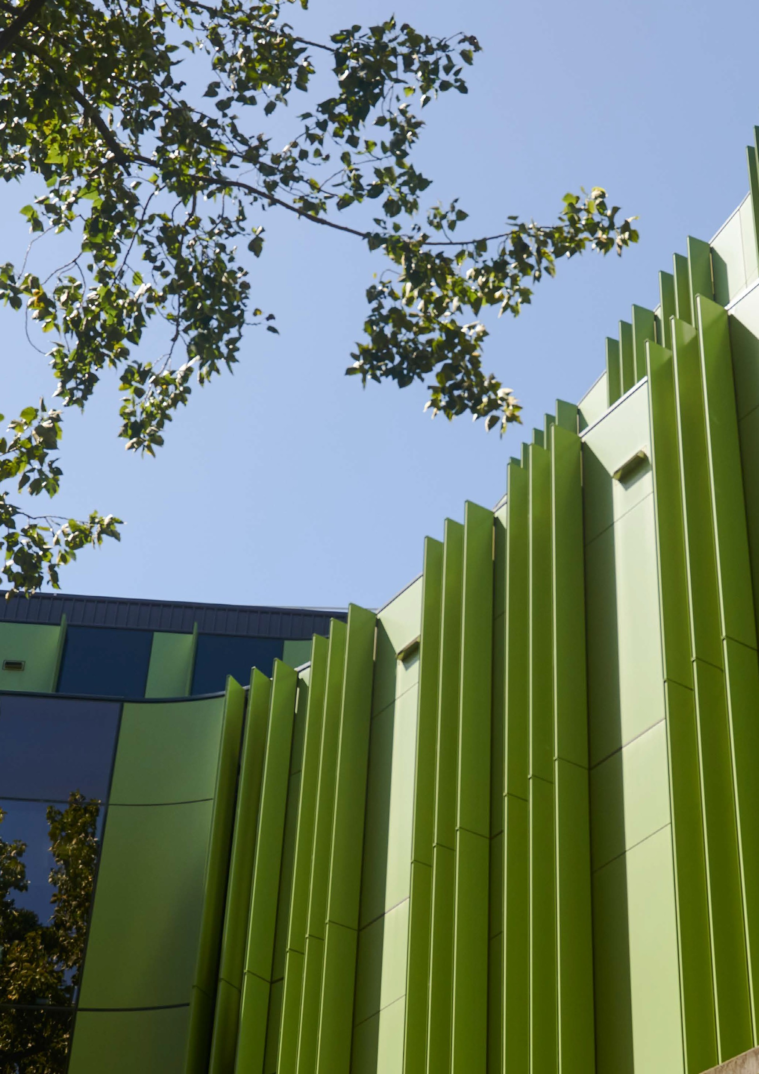
26

27

“I am proud to be a part of an organisation that is proactively embracing diversity and inclusion across the spectrum of what makes us different, including disability. I believe the DIAP is one important step in doing this. As someone with lived experience of
UNSW Disability Inclusion Action Plan 2022 – 2025
disability I look forward to seeing this implemented in a way that further supports equity across our student and staff community.”
Roshana Sultan
UNSW Disability Champion 2021-2022
Program Manager of Viral Immunology Systems, The Kirby Institute

28

Suppliers and partners

Action Measures Responsibility Timeframe

Demonstrate alignment of commitment around suppliers and partners within the 2022 – 2025 Disability Inclusion Action Plan.
Explore opportunities beyond disability enterprises and include procurement
of accessible products and services in ICT procurement processes.
DIAP 2022 – 2025 to include references to suppliers and partners and commitment to consider disability inclusion in procurement decisions.
Incorporate specific relevant standards (Australian ICT procurement standard
AS EN 301 549 (EN301))
around procurement of accessible ICT into the assessed functional/non- functional elements of the software platform.
Division of EDI
- Access, Equity & Inclusion with Office of Chief Financial Officer
- Procure to Pay
Office of Chief Financial Officer
- Procure to Pay
June 2022

June 2022

29

Communications, marketing and events

Action Measures Responsibility Timeframe

Identify a clear leader responsible for developing and implementing accessible policies and practices in communication and marketing.

Senior leader to oversee the development of a policy for accessible
Communications, Marketing and Events supported by
a new EDI Guidelines joint project between EDI and DEE.

Ensure all stakeholders are briefed on the policy and procedures and are suitably equipped to implement the activities.
Comprehensive existing UNSW Events checklist and resources for accessible events (in person and online) to be reviewed
in consultation with the Australian Network on Disability for any gaps and potential improvements.
Checklist and resources for accessible events to be disseminated across University, Faculty-based and hospitality events as well as other areas that may occasionally manage events.
A single overarching executive leader for Marketing, Communications and Events to be nominated as well as leaders in sub- sections of Corporate Communications and Brand; Faculty Communications; Future Students and Website.
Accessible Communications and Events Policy developed.

Disseminate policy communications as appropriate in induction, training and on HR Hub.

Resources reviewed, gaps identified, improvements made and resources re- published.

Checklist and supporting materials developed and disseminated appropriately.
Vice-President (VP) External Engagement

VP External Engagement with guidance from the DIAP Project Manager (and Australian Network on Disability) and
in collaboration with key business areas
VP External Engagement and HR

Director of Strategic Events with support from Division of EDI – Access, Equity & Inclusion and Australian Network on Disability
Director of Strategic Events with support from Division of EDI – Access, Equity & Inclusion (DIAP Project Manager) and EDI Communications
June 2022

December 2023
UNSW Disability Inclusion Action Plan 2022 – 2025

December 2023

December 2022

June 2023

30

UNSW Canberra

Action Measures Responsibility Timeframe

UNSW Canberra to nominate a Disability Executive Sponsor.

UNSW Canberra Disability Executive Sponsor or their representative to
be engaged in the DIAP Implementation Group.
Monitor the progress of the UNSW Canberra Library Accessibility Working Group.

Improve institutional understanding of the provision of services for students with disability at UNSW Canberra.

Ensure continuity and coherence of service by maintaining an accessible institutional contact person for staff and students with disability at UNSW Canberra.
Monitor upgrades and improvements made by Australian Defence
Force Academy (ADFA) in response to the 2021 Design for Dignity premises audit report of UNSW Canberra public and teaching spaces.
Expressions of Interest for UNSW Canberra Disability Executive Sponsor to be opened and candidate selected.

UNSW Canberra Disability Executive Sponsor included in the DIAP Implementation Group.

UNSW Canberra Disability Executive Sponsor to report to the DIAP Implementation Group on the progress of the UNSW Canberra Library Accessibility Working Group.
UNSW Canberra Disability Executive Sponsor to report to the EDI Board on Equitable Learning
Services for students with disability at UNSW Canberra (achievements and challenges).

EDI Manager at UNSW Canberra to maintain the role of Disability/
Accessibility Liaison Officer for staff and students.

UNSW Canberra to report annually to EDI Board on any improvements made by ADFA to UNSW Canberra public and teaching spaces,
including gaps and solutions where possible.
Division of EDI – Access, Equity & Inclusion (DIAP Project Manager) with UNSW Canberra Faculty Executive Director
Division of EDI – Access, Equity & Inclusion (DIAP Project Manager)

UNSW Canberra Disability Executive Sponsor

UNSW Canberra Disability Executive Sponsor with
PVC ESE –
Student Success – Equitable Learning Services
UNSW Canberra Faculty Executive Director

UNSW Canberra Faculty Executive Director
December 2022

January 2023 and ongoing

March 2023

December 2023

Ongoing

June/July 2023
June/July 2024

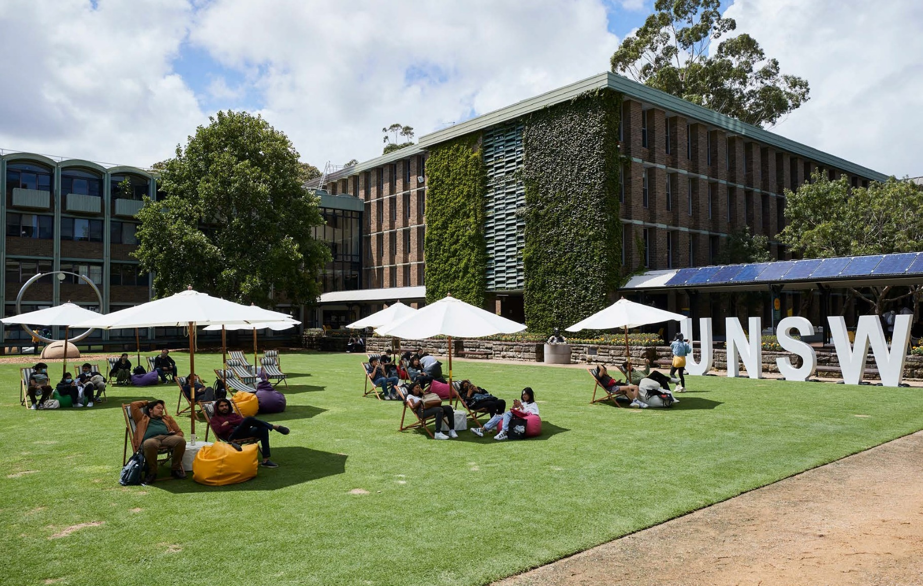
31

UNSW Disability Inclusion Action Plan 2022 – 2025
“The DIAP clearly outlines what support students with disability will have from the minute they choose to study at UNSW. It is not merely
an act of solidarity, but an opportunity to stand by UNSW’s commitment in ensuring everyone is respected and treated with dignity.”
Aaron, UNSW student, B Advanced Science
Member of the Student Lived Experience Advisory Group

32

33

Priority: experiences
Objective: Learning, teaching and working at UNSW are inclusive and equitable experiences

Teaching and learning
(including Universal Design for Learning (UDL) /Assistive Technology)

Action Measures Responsibility Timeframe

Identify and formalise a leader responsible for developing strategies,
guidelines, practices and updating policies where appropriate, to support widespread creation, delivery and evaluation of accessible education at UNSW.
Update the Guidelines for Accessible Blended and Online Courses and expand them to include all kinds of courses.
Consider adding ‘inclusion’ as a quality target in a review of the Education Quality Policy so that Universal Design for Learning (UDL) is
considered in quality reviews of education services.
Leader identified and communicated to key stakeholders. Leader or their representative is actively engaged in the DIAP Implementation Group.

Guidelines for Accessible Blended and Online Courses updated and expanded.

Concept of inclusion considered in review of the Education Quality Policy, with reference to Assessment Design
Procedure, and outcome reported to the DIAP Implementation Group.
PVC Education & Student
Experience (ESE)

PVC ESE
- Accessible Education Lead

PVC ESE
- Accessible Education Lead
June 2022 and ongoing

June 2023
UNSW Disability Inclusion Action Plan 2022 – 2025

December 2022

34

Include an introduction to the principles of UDL and best practice at UNSW, and the new self-paced UDL Moodle online learning module available for all teaching staff in Teaching and Learning programs.

Ensure consultation with people with disability at the design phase of any new developments in the education space.
Self-paced UDL Moodle course.
Staff participating in the UDL Moodle course to be surveyed and outcomes reported to the DIAP Implementation Group.
UDL included in Teaching and Learning programs; Foundations of University Learning and Teaching (FULT),
Academic Development (seminars, workshops and presentations) and Teaching Accelerator Program
(TAP), the mandatory new academic induction for all teaching-facing roles.
Accessible Education Lead introduced to the Student Lived Experience Advisory Group to enable
consultation as required and create connection with other relevant areas (e.g. Students as Partners, Course Design Institute).
PVC ESE
- Accessible Education Lead

Division of EDI
- Access, Equity & Inclusion
March 2023

November 2022

Workplace adjustments

Action Measures Responsibility Timeframe

Develop a standalone Workplace Adjustment Policy and Procedure.

Review and update the Reasonable Adjustment Guidelines for Managers of Staff and Potential Staff with Disabilities to support the Workplace Adjustment Policy (once created).
Policy and procedure developed and agreed by UNSW Management Board; including review of the requirement for medical certification.
Updated Guidelines and/ or toolkit (exact format dependent on updated UNSW Policy framework).
Division of EDI
  - Access, Equity & Inclusion

Division of EDI
  - Access, Equity & Inclusion
June 2023

December 2023

35

Review the Disability Travel Assistance Fund with a view to extending assistance
to professional as well as academic staff for conference travel.
Conduct a focus group or interviews with staff with current workplace
adjustments to gain insight into their experience of
the request, approval and review process as part of the development of the consolidated policy and procedure.
Promote the new Workplace Adjustment Policy, Procedure and Guidelines to all staff.

Promote the new Workplace Adjustment Policy,
Procedure and Guidelines to potential candidates via UNSW’s careers and EDI webpage to encourage applications from people with disability.
Promote and proactively offer adjustments for people with disability.

Proactively seek feedback on, and have a designated contact to manage,
the Workplace Adjustment policy and process, including feedback and data/ information monitoring.
Disability Travel Assistance Fund Reviewed.

Focus group consultation and/or interviews held.

All Staff email.
Update to Policy Register.
Update to (new) dedicated HR Hub Supporting Staff with Disability page.
Workplace Adjustment policy to be updated on UNSW EDI website and Careers page, and copy adapted to include more compelling and inclusive language.

Include information about adjustments in Hiring Managers’ training, in new staff inductions, on HR Hub and in Managers’ toolkit.
Feedback process to be included as part of EDI’s accessibility feedback form and feedback sought at various points in the adjustments process.
Maintain designated workplace adjustments contact in the Division of EDI.
Division of EDI
- Access, Equity & Inclusion

Division of EDI
- Access, Equity & Inclusion (DIAP Project Manager)

Division of EDI
- Access, Equity & Inclusion and EDI Comms with HR

Division of EDI
- Access, Equity & Inclusion and EDI Comms, HR – Talent Acquisition

Division of EDI
- Access, Equity & Inclusion with HR – Talent Acquisition
Division of EDI
- Access, Equity & Inclusion
October 2022

December 2022

2023-2024
UNSW Disability Inclusion Action Plan 2022 – 2025
(when policy finalised and approved)

2023-2024
(when policy finalised and approved)

June 2022-
Dec 2023

June 2023

36

Educational adjustments

Action Measures Responsibility Timeframe

Develop a standalone Students with Disability Support Policy and associated Guidelines.

Continue Phase 2 implementation of the Student Disability Management System
Simplicity Access to support improved and streamlined support services for students.
Students with Disability Support Policy and associated Guidelines developed and approved by Management Board;
communicated to all UNSW staff.
Full ICT integration of Simplicity Access.
PVC ESE –
Student Success – Equitable Learning Services in consultation with other key business areas.
PVC ESE –
Student Success – Equitable Learning Services with Chief Technology & Infrastructure Officer
December 2023

December 2022

Create a full annual report to EDI Board from the new integrated Simplicity Access Report on a full anonymised statistical breakdown of students with disability
at UNSW and services provided to them.
Proposed content of report confirmed with DIAP Project Manager and report created.
PVC ESE –
Student Success – Equitable Learning Services
December 2023

37

Supporting Indigenous students with disability

Action Measures Responsibility Timeframe

Identify and formalise a leader responsible for
ensuring that UNSW is an accessible and welcoming environment for Indigenous students with disability.
Ensure that Indigenous students with disability are considered in service provision and all other initiatives that UNSW undertakes in relation to students with disability.
Enhance institutional awareness of current state and gap analysis of services for Indigenous students with disability at UNSW.
Nura Gili to nominate an Indigenous Students with Disability Lead.

Nura Gili Students with Disability Lead or their representative to be included on the DIAP Implementation Group.

Nura Gili Students with Disability Lead to report to EDI Board on the prevalence of Indigenous students
with disability and case management arrangements with other UNSW business areas, highlighting achievements and potential areas for improvement.
PVC Indigenous – Nura Gili Indigenous Programs

PVC Indigenous – Nura Gili Indigenous Programs

PVC Indigenous – Nura Gili Indigenous Programs
June 2022

June 2022 and ongoing
UNSW Disability Inclusion Action Plan 2022 – 2025

December 2022

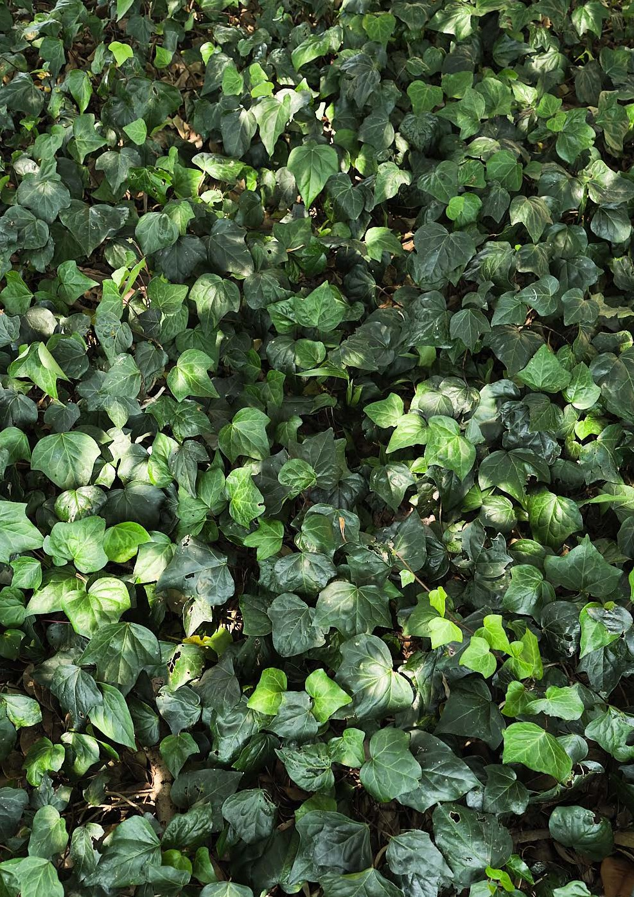
38

39

“Having a DIAP extends beyond the support received through ELS by committing to actions that will improve our future. This plan will ensure students can enter a classroom and feel like they have a fair go at their courses and have a better chance of completion.”
UNSW Disability Inclusion Action Plan 2022 – 2025

Nayonika, UNSW student, B Arts/Law
Member of the Student Lived Experience Advisory Group
SRC president

40

Priority: enablers
Objective: Continuous improvements in accessibility are embedded in frameworks and governance and led by UNSW innovation

Commitment and campus culture

Action | Measures | Responsibility | Timeframe
Executive Sponsorship | Election of an inaugural | Division of EDI | June 2022
of the Disability Inclusion | Executive Sponsor. | – Access, Equity
Action Plan 2022 – 2025 |  | & Inclusion
(DIAP) to demonstrate
the endorsement and
commitment at an Executive
level.
Include an explicit statement | Statement included in DIAP | Division of EDI | June 2022
in the DIAP that UNSW | 2022 – 2025 and in HR/ | – Access, Equity
is committed to the | Recruitment Plan. | & Inclusion;
employment of people with |  | HR
disability.
Review statement regarding | Statement included on | Division of EDI | June 2022
a commitment to employing | EDI website and on | – Access, Equity
people with disability on | Jobs@UNSW website. | & Inclusion and
UNSW’s external websites. |  | EDI Comms; HR
Ensure that the DIAP is | DIAP Implementation Group | Division of EDI | June 2022
incorporated into UNSW | established to replace DIAP | – Access, Equity | and ongoing
governance structures and | Steer Co and DIAP Project | & Inclusion, DIAP
that efforts towards the | Team. DIAP Implementation | Project Manager
plan are actively monitored | Group to report at least
and reported through | twice per year to EDI Board.
appropriate channels.
Consult with students | Disability Champions to | Division of EDI | Ongoing
including the UNSW | be included as part of the | – Access, Equity
Disability Champions | DIAP Implementation Group; | & Inclusion
Network to ensure that | include in Faculty/Division
there is an active element of | EDI Plans.
co-design in all aspects of
UNSW’s activities.

41

Provide regular and ongoing learning and development opportunities to professional and academic staff members throughout their employment life cycle to ensure that they are disability confident in the workplace.
Schedule annual Disability Confident trainings at a cadence to support both new and experienced staff across key business areas of UNSW.
Division of EDI
- Access, Equity & Inclusion;
PVC ESE –
Student Success
- Equitable Learning Services;
Australian Network on Disability
Ongoing

Create a specific Supporting Staff with Disability page on HR Hub where resources and relevant policies and procedures can be housed.

Develop UNSW-specific Toolkit for Managers, which includes advice on inclusive job design, recruitment
and selection, supporting staff with a disability, links to relevant UNSW-specific policies and procedures, and contextualise within legislative framework and UNSW Strategy.
Improve feedback capability and process across all areas impacting students and staff with a disability.
Page created and populated with relevant materials including policies, procedures, Australian Network on Disability factsheets including AND’s publication, Welcoming Customers with Disability, and information regarding JobAccess services.
Guidelines/Toolkit developed and published on UNSW HR Hub page with accompanying communications plan.

Create a single point feedback form to be housed on the EDI website which can be used as a data source to inform:
workplace adjustments; ICT; premises; student services; events, marketing and communications.
Division of EDI
- Access, Equity & Inclusion (DIAP Project Manager) with HR

HR – Talent Acquisition with Division of EDI
- Access, Equity & Inclusion (DIAP Project Manager)

Division of EDI
- Access, Equity & Inclusion (DIAP Project Manager) with EDI Comms
June 2023

December 2023
UNSW Disability Inclusion Action Plan 2022 – 2025

December 2022

42

Improve the quality of, and relevant business areas’ access to, data around staff with disability at all levels and their experiences at UNSW.

Participate in the Access and Inclusion Index at regular intervals to support UNSW to monitor progress effectively and consistently towards access and inclusion goals.
Access to and quality of data relating to staff with disability to be included in the Division of EDI’s data improvement working group Terms of Reference.

Participation in the Access and Inclusion Index in 2024 to assess progress on accessibility improvements and plan for 2025 DIAP.
Division of EDI
- Access, Equity & Inclusion with HR – Workforce Analytics and Reporting and UNSW Planning & Performance (UPP)
Division of EDI
- Access, Equity & Inclusion (DIAP Project Manager)
June 2022

December 2024

43

Innovation and research

Action Measures Responsibility Timeframe

Seek feedback and collect data to understand the impact and success of the Disability Travel Assistance Fund for Academic Staff with Disabilities.

Enhance connections between the UNSW Disability Innovation Institute (the Institute) and the Disability Champions and their network, and the Institute and DIAP.
Better utilise the research and practical expertise of innovators on campus, including the Institute and Equitable Learning Services (ELS).

The Institute visibility as advisor on inclusive research methods and inclusive education to be increased, with initial
contact with and filtering by general EDI channels.

Utilise the Institute’s expertise to oversee DIAP implementation evaluation, via DIAP Implementation Group.
Include the opportunity for feedback on the Disability Travel Assistance Fund as well as feedback on the Workplace Adjustments Policy in accessibility measures.
The Institute Director to be nominated as the inaugural Executive Sponsor, of the UNSW DIAP, and Chair of the Implementation Team.

Create and use multimedia assets to raise awareness across UNSW of expertise and experience in disability inclusion. Prioritise learning modules for UNSW staff
on accessible marketing, communications and events, and inclusive research practices.

The Institute to be promoted through EDI website, HR Hub Disability page and other avenues as appropriate.

The Institute Director to be nominated as the
inaugural Executive Sponsor, Disability Inclusion at UNSW, and Chair of the DIAP Implementation Group.
Division of EDI
- Access, Equity & Inclusion (DIAP Project Manager)

Division of EDI
UNSW Disability Innovation Institute

Division of EDI
- Access, Equity & Inclusion (DIAP Project Manager)
UNSW Disability Innovation Institute
Equitable Learning Services (ELS)
Division of EDI
- Access, Equity & Inclusion (DIAP Project Manager) with EDI comms and HR
UNSW Disability Innovation Institute
Division of EDI
UNSW Disability Innovation Institute
December 2022

June 2022
UNSW Disability Inclusion Action Plan 2022 – 2025

June 2023

June 2023

June 2022

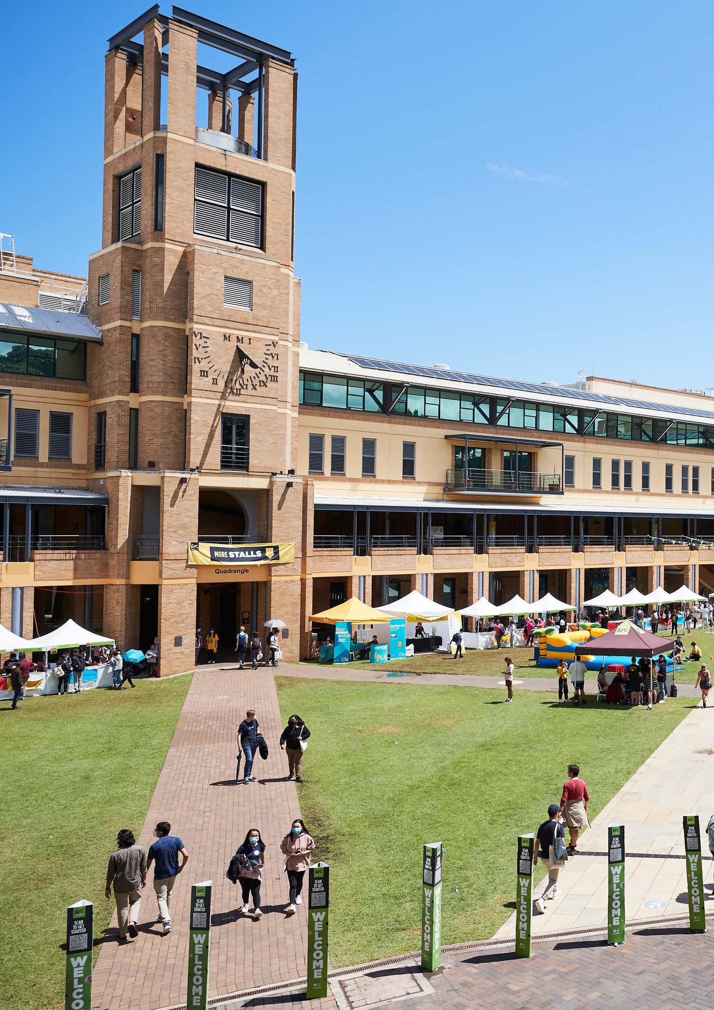
44

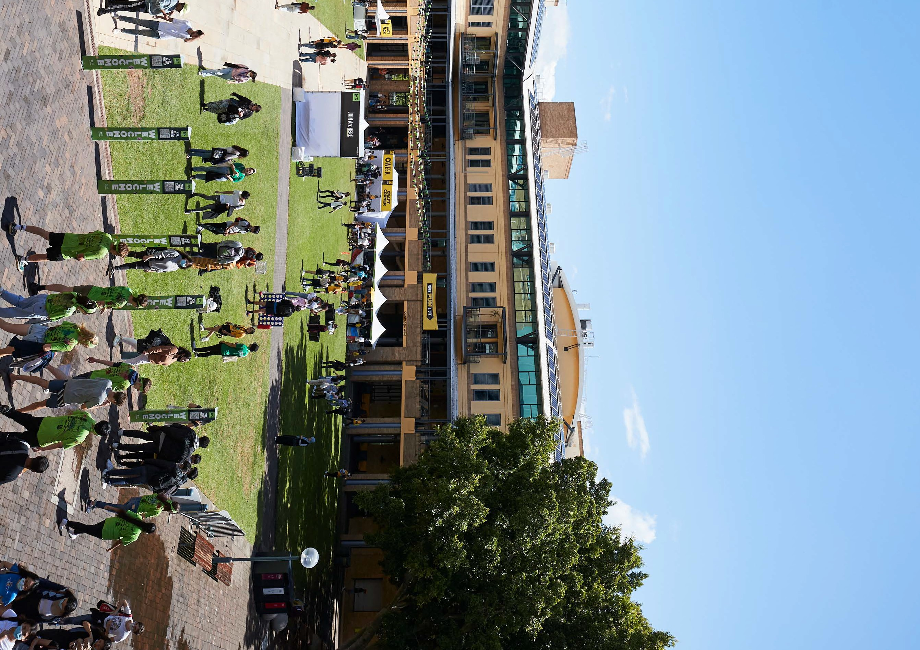
45

UNSW Disability Inclusion Action Plan 2022 – 2025

46

Implementation and evaluation

The DIAP Steering Committee and DIAP Project Team developed the 2022 – 2025 DIAP after consulting extensively across the University. Before the DIAP is implemented, a new DIAP Implementation Group will be formed by the Division of EDI, and chaired by Executive Sponsor, Professor Jackie Leach Scully.
The DIAP Implementation Group will be responsible for ensuring the University achieves the DIAP’s objectives. This includes monitoring performance and outcomes, as well as providing a forum for consultation with stakeholders, staff and students to discuss the plan’s success.
The DIAP Implementation Group will report to the EDI Board on progress and review the DIAP every three years.

Acknowledgement of Country
edi.unsw.edu.au
Cricos code 00098G
We would like to acknowledge the Bedegal (Kensington campus), Gadigal (City and Art & Design Campuses) and Ngunnawal people (Australian Defence Force Academy in Canberra) who are the traditional custodians of the lands where each campus of UNSW is located.

